PYTHON WEB DEVELOPMENT – TUTORIALS

CHAPTER 3: STRING HANDLING MANAGEMENT
TOPICS COVERED
3.1 WHAT IS STRING
3.2 ASSIGNING VALUES TO VARIABLES
3.3 USE OF __doc__ METHOD
3.4 STRING HANDLING OPERATIONS
3.5 STRING HANDLING METHODS
3.6 STRING BUILT IN FUNCTIONS SUPPORT

3.1 WHAT IS STRING
In Python, anything inside single quotation or double quotations are treated as string values.
In Python 2.7 series, string values are considered as byte code value presentations
In Python 3.4 and greater series, string values are treated as Unicode value presentations.
3.2 ASSIGNING VALUES TO VARIABLES
There are two types of value assignment is available in python,
- Multi value assignment (ex: name,city=’rajesh’,’dindigul’)
- Multiple value assignment(ex: a=b=c=10)
3.3 USE OF __doc__ METHOD
In Python, anything inside triple quotations are called as doc string used to describe something useful about program source code.
Example:
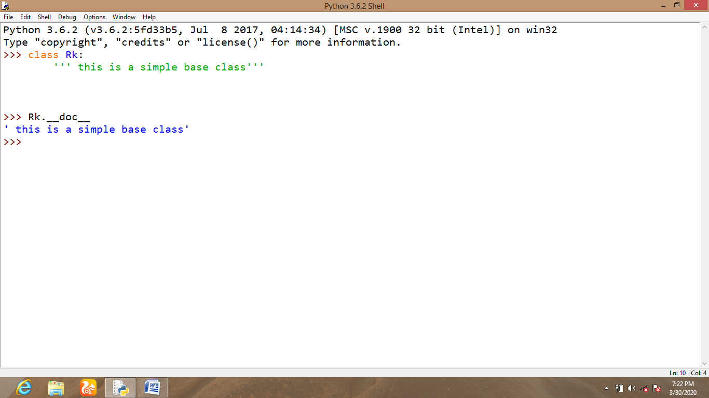
>>> class Rk:
‘’’ this is a simple class’’’
>>> Rk.__doc__
This is simple class

3.4 STRING HANDLING OPERATIONS
1. INDEXING – Accessing values in a word using its memory location
2. SLICING – Returns a particular part of string values using starting and ending value
3. RANGING – Used to return values from either beginning or up to end of value
Example:
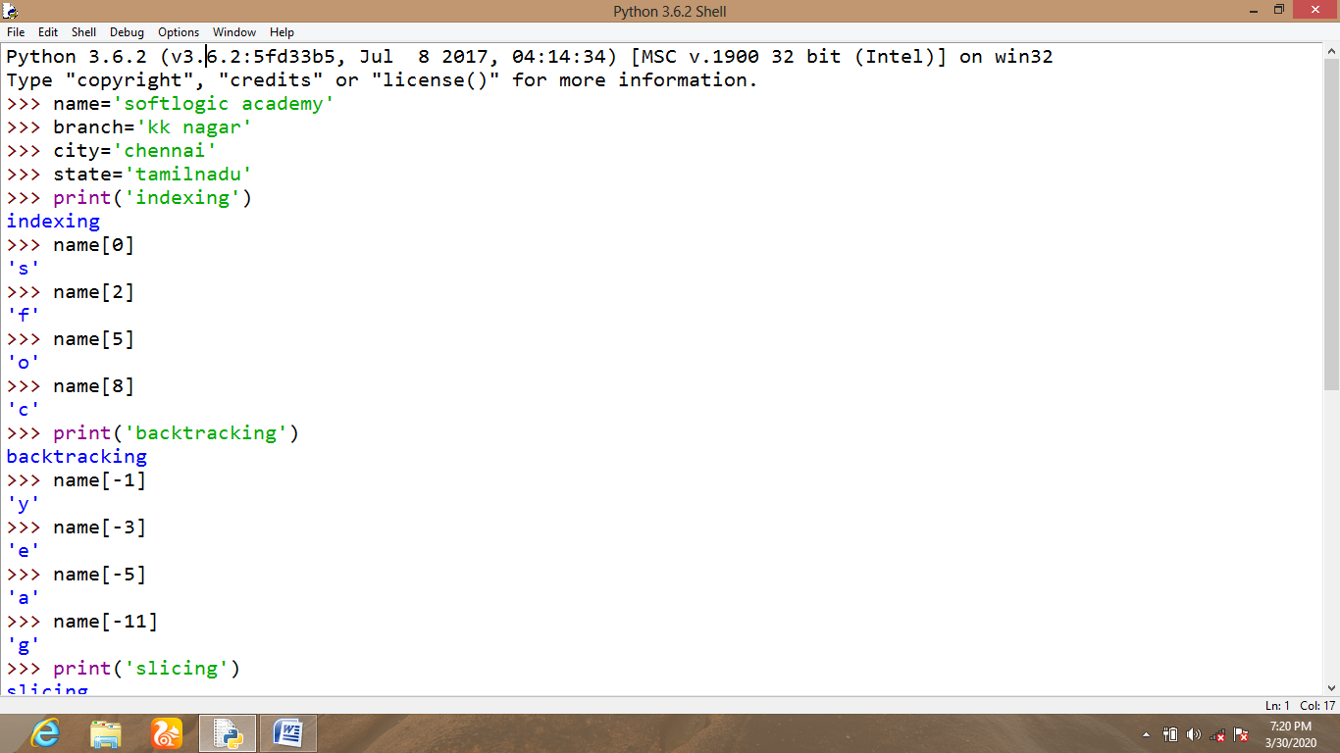

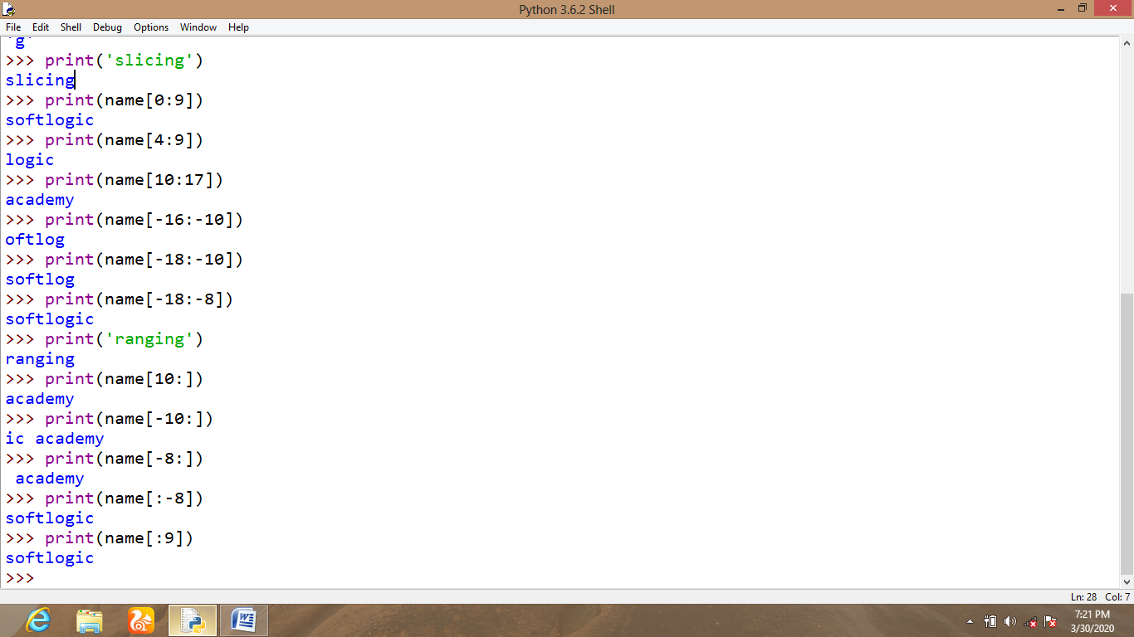
3.5 STRING HANDLING METHODS
1. STRING CONCATENATION
2. STRING REPETITION
3. STRING FORMATTING
- NORMAL FORMATTING
- AUTOMATED FORMATTING
- GENERAL FORMATTING
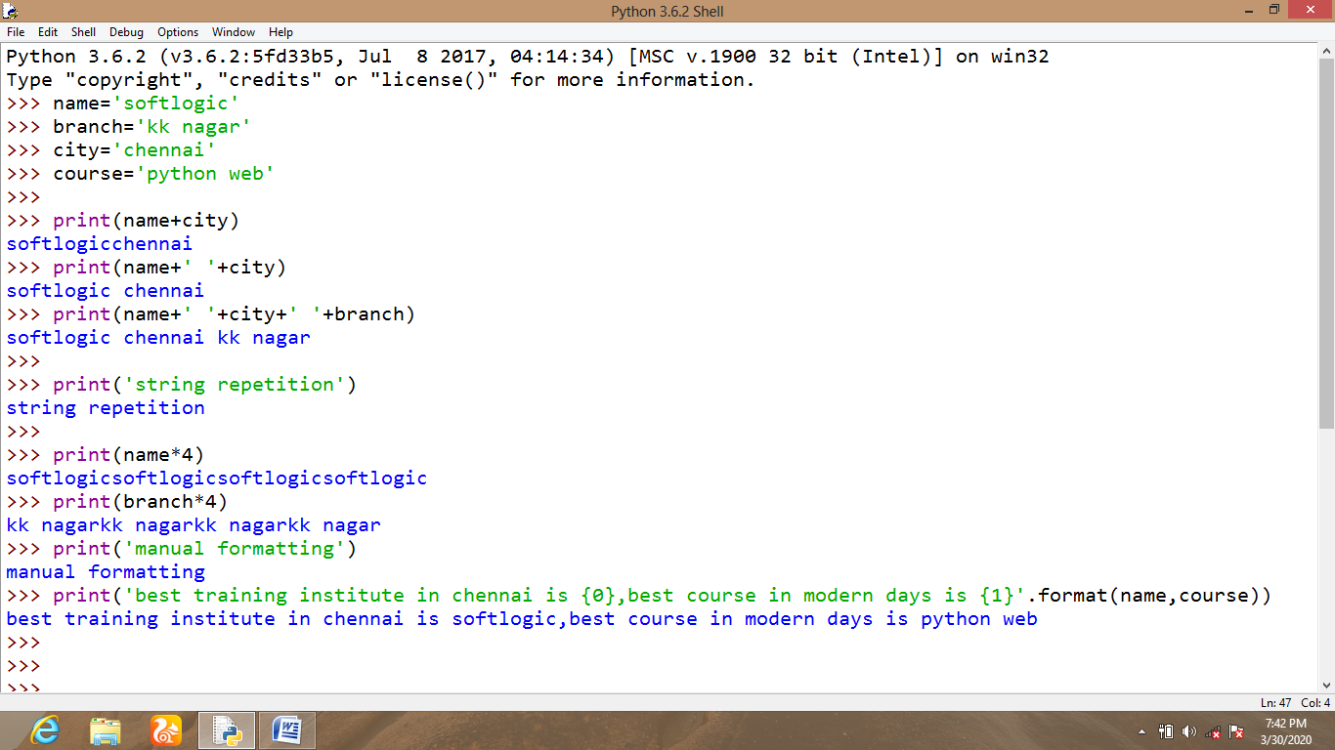
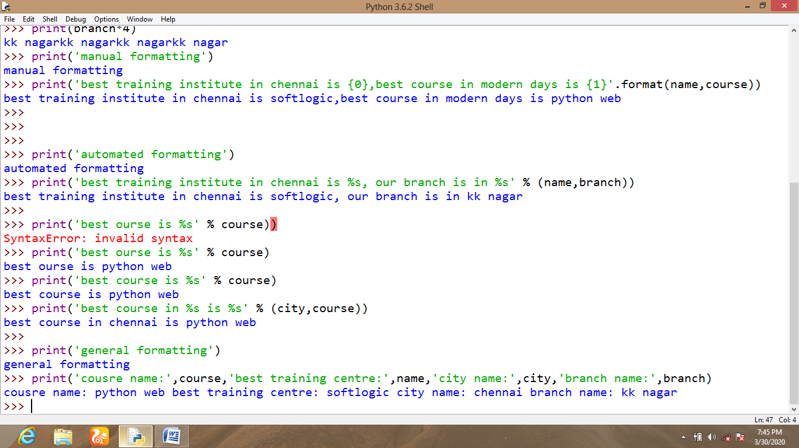

3.6 STRING HANDLING BUILT IN FUNCTION SUPPORT
Python provides the following built in functions to support strings.
